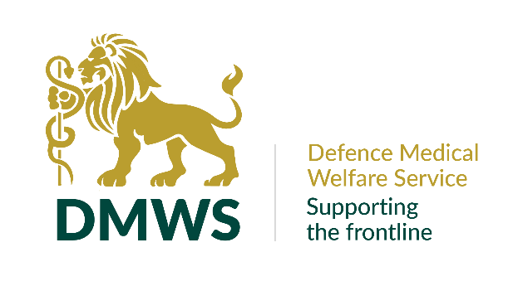

OFFICE ADMINISTRATOR

Full time permanent position

35 hours per week, Monday to Friday 9am to 5pm
Part time working is not possible due to coverage model.

YOUR PURPOSE
As an administrator, you will play a key role in ensuring the smooth running of HQ and the wider organisation by carrying out varied tasks and conducting general administration. As a member of the HQ team, you will often be the first point of contact for the whole organisation dealing with internal and external audiences.

YOU WILL HAVE:

- A positive attitude with can-do approach towards tasks
- Excellent communication on the phone and face-to-face
- Excellent IT skills, including experience of using Excel, Word and ideally Microsoft Teams
- The confidence and ability to prioritise conflicting tasks and deadlines
- Ability to adapt to changing situations, work flexibly and enjoy variation
- Evidence of organisational and administrative skills
- Self-motivation and the ability to use your own initiative
- An efficient working style and be able to put forward suggested process improvements.
- A methodical approach, with an exceptional eye for detail
- An excellent team working ethic

YOU WILL :-

- Ensure the telephones are covered at HQ, acting as first contact for queries; resolving, signposting, or passing onto other team members.
- Assist with recruitment as required, including advertising, co-ordinating interviews, and the on-boarding process of new hires.
- Be responsible for the ordering of stationery, uniforms, and ad hoc resources.
- Co-ordinate cost effective travel arrangements including hotel bookings, flights, trains, and ad-hoc journeys.
- Welcome visitors to the premises and cater for them during their visit. Whilst this includes presentation of shop-bought platters, food hygiene, food preparation (such as salads), and tidying the kitchen and conference room after a lunch/visit is part of the role.
- Have a current Driving Licence and access to a vehicle, due to the remote location of our office. There will be an expectation to travel short distances to visit local shops when providing lunches, posting parcels and other required resources.
- Collate information based on employee contract changes to be used for the payroll.
- Co-ordinate audit tasks including identifying and chasing up gaps in HR data, chasing the wider team for them to complete outstanding training/tasks and recording credit card expenditure.
- Develop working practices and recommend effective and efficient changes to the Office Manager.
- Organise and manage all staff mobile equipment including replacing lost or damaged items. Assist staff with IT issues and liaise with the external IT consultant when required.
- Deal with maintenance issues at HQ, including liaising with the landlord and any contractors as necessary.
- Perform regular health and safety checks and flag any potential hazards (training will be given).
- Actively contribute to a culture of innovation, resourcefulness, and best practice to make the best use of your time and others.
- Complete other ad hoc tasks as and when required.
- Understand that legislation including GDPR, Equality Act, Health & Safety legislation and confidentiality/ sensitivity of patient information will be a part of your work, (training will be provided).
- Work in accordance with and promote our values which are: -

  - Commitment - We are passionately committed in heart and mind to the people we support, delivering our service whenever and wherever they happen to be.
  - Integrity - We act with integrity, consistency, and honesty in all that we do.
  - People - We support each other. We trust, encourage, and develop our staff, because we know that it’s our people who make us what we are.
  - Working Together - We work collaboratively together and with others to provide the best possible service to the people we support

BENEFITS OF WORKING WITH DMWS

We recognise that without our staff we are nothing, they are the most important asset that we have. We offer employees the following benefits: -

Annual Leave
We give employees 30 days a year annual leave plus Public Holidays (pro-rata'd for part-time employees).

Pension
Auto enrolment onto DMWS workplace pension scheme – subject to eligibility. You will make a minimum contribution of 5% which DMWS will match. Contributions will be matched up to 6% by DMWS. There is an option to participate in a salary sacrifice scheme.

Death in Service Scheme
Three times your annual salary to nominated beneficiaries - subject to eligibility

Smart Health
Access to a 24/7 virtual GP service, with a counselling service and on-line help and support around health and well-being matters

Work-based Parking/Mileage
For those who pay to park at their work-base, fees are repaid through expenses. Mileage claims are reimbursed in line with HMRC guidelines.

Enhanced Sick Pay
Enhanced sick pay scheme for all employees upon completion of their probationary period.

Staff Recognition
Staff are regularly recognised for their work by the leadership team and their peers, via internal events, social media, and industry awards.

Personal Development Programme
DMWS supports employee continuing professional development and training.

Above all, being part of the DMWS team, means that you are making a difference to the lives of those working on the frontline.

