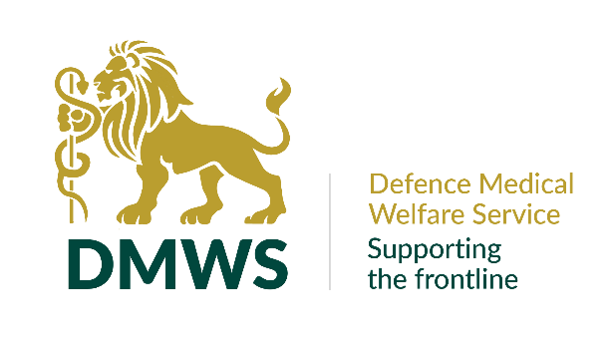
OFFICE MANAGER

Full time permanent position

35 hours per week, Monday to Friday 9am to 5pm
Part time working is not possible due to coverage model.

YOUR PURPOSE
As Office Manager you will be pivotal to the smooth running of HQ and the wider organisation. You will be line manager to the Office Administrator and be responsible for the overall delivery of administrative functions across HQ.

YOU WILL HAVE:

- Line manager experience
- A positive attitude with can-do approach towards tasks
- Excellent communication on the phone and face-to-face
- Proven negotiating skills
- Excellent IT skills, including experience of using Excel, Word and ideally Microsoft Teams
- The confidence and ability to prioritise conflicting tasks and deadlines
- Ability to adapt to changing situations, work flexibly and enjoy variation
- Evidence of organisational skills
- Self-motivation and the ability to use your own initiative
- An efficient working style and be able to implement process improvements.
- A methodical approach, with an exceptional eye for detail
- An excellent team working ethic

YOU WILL :-

- Ensure the telephones are covered at HQ.
- Oversee the recruitment process, to ensure compliance with current legislation. This in relation to new hires and variations to existing staff contracts. When called upon taking accurate and confidential minutes.
- Oversee cost effective travel arrangements including hotel bookings, flights, trains, and ad-hoc journeys.
- Have a current Driving Licence and access to a vehicle, due to the remote location of our office.
- Ensure security clearances are sought for new starters and renewed when required.
- Assist the Senior Leadership Team through diary management, booking travel, arranging VIP visits and meetings.
- Continually review and document processes to allow effective working, training, and accountability, with a focus on scalability.
- Liaise with our external IT and HR consultants on complex matters.
- Oversee facilities management at HQ.
- Manage contractor contracts (e.g. photocopier, window cleaners, coffee machine), ensure renewals are flagged, actioned and negotiated to achieve best value.
- Co-ordinate H&S compliance across the organisation.
- Plan and action staff events (at least annually).
- Actively contribute to a culture of innovation, resourcefulness, and best practice to make the best use of your time and others.
- Complete other ad hoc tasks as and when required.
- Understand that legislation including GDPR, Equality Act, Health & Safety legislation and confidentiality/ sensitivity of patient information will be a part of your work, (training will be provided).
- Work in accordance with and promote our values which are: -

  - Commitment - We are passionately committed in heart and mind to the people we support, delivering our service whenever and wherever they happen to be.
  - Integrity - We act with integrity, consistency, and honesty in all that we do.
  - People - We support each other. We trust, encourage, and develop our staff, because we know that it’s our people who make us what we are.
  - Working Together - We work collaboratively together and with others to provide the best possible service to the people we support

BENEFITS OF WORKING WITH DMWS

We recognise that without our staff we are nothing, they are the most important asset that we have. We offer employees the following benefits: -

Annual Leave
We give employees 30 days a year annual leave plus Public Holidays (pro-rata'd for part-time employees).

Pension
Auto enrolment onto DMWS workplace pension scheme – subject to eligibility. You will make a minimum contribution of 5% which DMWS will match. Contributions will be matched up to 6% by DMWS. There is an option to participate in a salary sacrifice scheme.

Death in Service Scheme
Three times your annual salary to nominated beneficiaries - subject to eligibility

Smart Health
Access to a 24/7 virtual GP service, with a counselling service and on-line help and support around health and well-being matters

Work-based Parking/Mileage
For those who pay to park at their work-base, fees are repaid through expenses. Mileage claims are reimbursed in line with HMRC guidelines.

Enhanced Sick Pay
Enhanced sick pay scheme for all employees upon completion of their probationary period.

Staff Recognition
Staff are regularly recognised for their work by the leadership team and their peers, via internal events, social media, and industry awards.

Personal Development Programme
DMWS supports employee continuing professional development and training.

Above all, being part of the DMWS team, means that you are making a difference to the lives of those working on the frontline.

