THE ROLE
Job Title: Welfare Officer Initial Base: Field-based
YOUR PURPOSE
You are responsible for providing a world class, responsive medical welfare service to service users and their families, by delivering superb practical and emotional support.
YOU WILL :-
- Work in an agile manner, being willing to put time and effort where organisational priorities require and approach your role with flexibility and enthusiasm.
- Ensure your services reflect the culture of DMWS and they celebrate diversity, engage staff and help the organisation to be an employer of choice.
- Deliver a weekly craft based support group within the region
- Provide a rapid, solution driven personal response in support of crisis situations, both when on duty and (in some services) when on call.
- Process referrals, correctly assessing the welfare needs of service users and their families with unfaltering professionalism and sensitivity.
- Give high quality emotional and practical support to relatives of seriously ill patients and to those who are bereaved.
- Be an enthusiastic ambassador for DMWS, liaising with stakeholders regarding patients, families as well as bigger picture matters.
- Recognise safeguarding issues quickly and immediately report any concerns regarding children or vulnerable adults to the appropriate agencies.
- Highlight risks to service delivery and work collaboratively with the Regional Manager to mitigate risk to patients and rectify issues as they occur.
- Keep meticulous records and ensure data/reports are provided in a timely manner, with full understanding of the need to demonstrate return on investment to other agencies.
- Properly maintain professional boundaries with clients and raise concerns appropriately.
- Enthusiastically promote the organisation, generate referrals and seize opportunities.
- Identify and gladly participate in fundraising and business development opportunities.
- Facilitate knowledge transfer with others and provide a listening ear to colleagues.
- Actively contribute to a culture of innovation, resourcefulness and best practice to make the best use of your time and others.
- Treat everyone with dignity and respect, abiding by our Diversity & Inclusion Policy at all times and challenging any unfair practices or behaviours.
YOU WILL HAVE:
- Excellent networking skills
- Motivation and drive: a proactive self-starter who can work independently and as part of a team
- Unfaltering professionalism and a passion for welfare services
- Honesty and integrity
- Good judgement and empathy for others
- Empathy with the service life environment
- Excellent written and verbal communication skills
- Ability to deliver interesting and impactful presentations
- Proven IT skills
- Counselling skills to provide support
- Experience of working in a health, social care or welfare environment
- Ability to keep accurate records and a good understanding of the importance of data
- To work in an agile, flexible manner, doing what it takes to get the job done.
- A working understanding of relevant legislation including GDPR, Equality Act, H&S legislation and an understanding of the Caldicott principles regarding the confidentiality and sensitivity of patient information.
- To work in accordance with and promote our values which are:-
  - Commitment - We are passionately committed in heart and mind to the people we support, delivering our service whenever and wherever they happen to be.
  - Integrity - We act with integrity, consistency, and honesty in all that we do.
  - People - We support each other. We trust, encourage and develop our staff, because we know that it’s our people who make us what we are.
  - Working Together - We work collaboratively together and with others to provide the best possible service to the people we support.
- A recognised Health & Social Care or Welfare qualification at Level 3 or other relevant qualification
- A current Driving Licence and access to a vehicle
- A willingness to travel on a regular basis and be away temporarily, including deployment if required.

MOBILITY & AGILITY
DMWS as a charity was originally set up in 1943 to provide a welfare service to the armed services during World War 2. Our staff deployed alongside the military to provide welfare support to the people who needed our help during times of conflict and have done this ever since.
We have always been able to be flexible and offer help when it is most needed. DMWS is an agile, responsive organisation, as proved during our response to the COVID-19 pandemic, with staff changing the way they provide services to our regular clients; as well as rolling up their sleeves and getting stuck in to provide support to NHS staff and other frontline services in ways we would never have predicted.
As an employee of DMWS, you need to be flexible and agile too whatever your role. There is no room for staid thinking or inflexibility. We provide creative, person-centred welfare support and our staff need to have an open mind in how they best do that.
Employees will be employed by DMWS and may not work in just one service or project. They may work for different managers and across different geographical areas during their employment with us.
Everything we do is driven by the needs of the people we serve, but it is by serving them best we experience great job satisfaction, knowing that we have made a real difference at the end of the day.
Because of the nature of our services, welfare officers in particular may need to deploy to areas of conflict. Whereas all our staff need to be willing to work at different locations in the short term, or on different projects, Welfare Officers and their managers may need to be ready to deploy to those areas of conflict, often at short notice if required to do so.
Before any Welfare Officer or Manager deploys to an area of conflict, they would:-
- Attend a medical and possibly be asked to be vaccinated against risks in the area that they will be going to;
- Complete Contractors Deploying on Operations (CONDO) Training;
- Be physically fit, able to carry out 55 kg in baggage, a daysack and Combat Body Armour
- Able to be in the correct state of mind to share washing/shower facilities, sleep on a camp bed for up to 3 months and share a large tent with others.
(Please note that Welfare Support Workers would not be expected to deploy to areas of conflict).
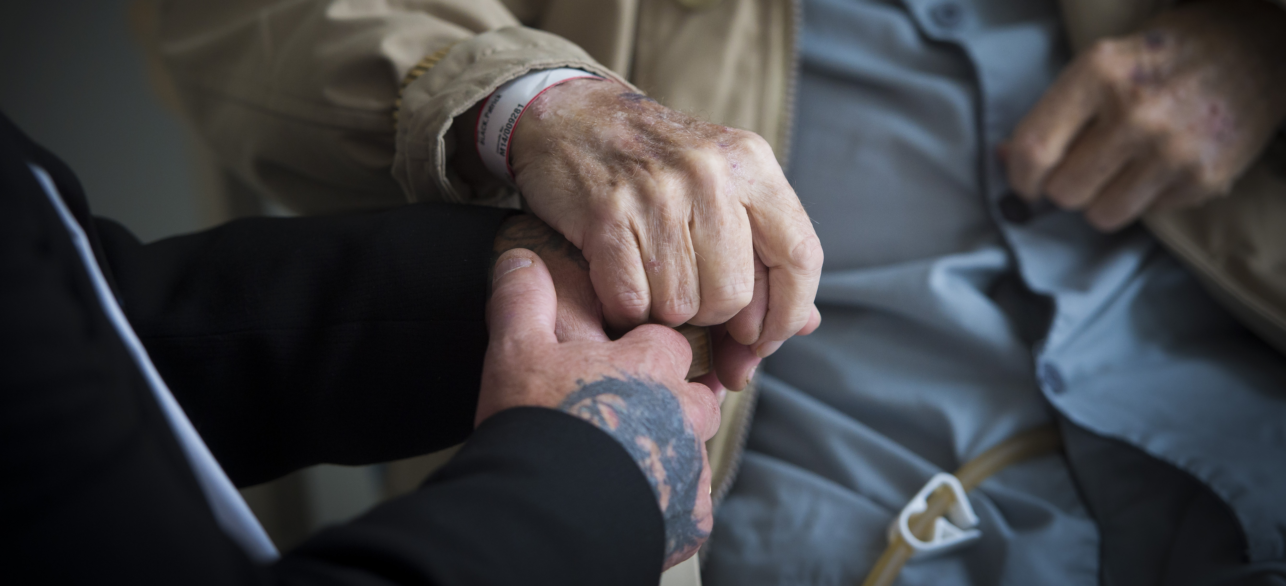

BENEFITS OF WORKING WITH DMWS
We recognise that without our staff we are nothing, they are the most important asset that we have. We offer employees the following benefits: -
Annual Leave
We give employees 30 days a year annual leave plus Public Holidays (pro-rata'd for part-time employees).

Pension
Auto enrolment onto DMWS workplace pension scheme – subject to eligibility. You will make a minimum contribution of 5% which DMWS will match. Contributions will be matched up to 6% by DMWS.

Death in Service Scheme
Three times your annual salary to nominated beneficiaries - subject to eligibility

Flexible Working
All flexible working requests are considered - many of our staff work flexible hours and work wholly, or partly from home.

Smart Health
Access to a 24/7 virtual GP service, with a counselling service and on-line help and support around health and well-being matters

Work-based Parking/Mileage
For those who pay to park at their work-base, fees are repaid through expenses. Mileage claims are reimbursed in line with HMRC guidelines.

Enhanced Sick Pay
Enhanced sick pay scheme for all employees upon completion of their probationary period.

Staff Recognition
Staff are regularly recognised for their work by the leadership team and their peers, via internal events, social media, and industry awards.

Personal Development Programme
DMWS supports employee continuing professional development and training.

Above all, being part of the DMWS team, means that you are making a difference to the lives of those working on the frontline.

