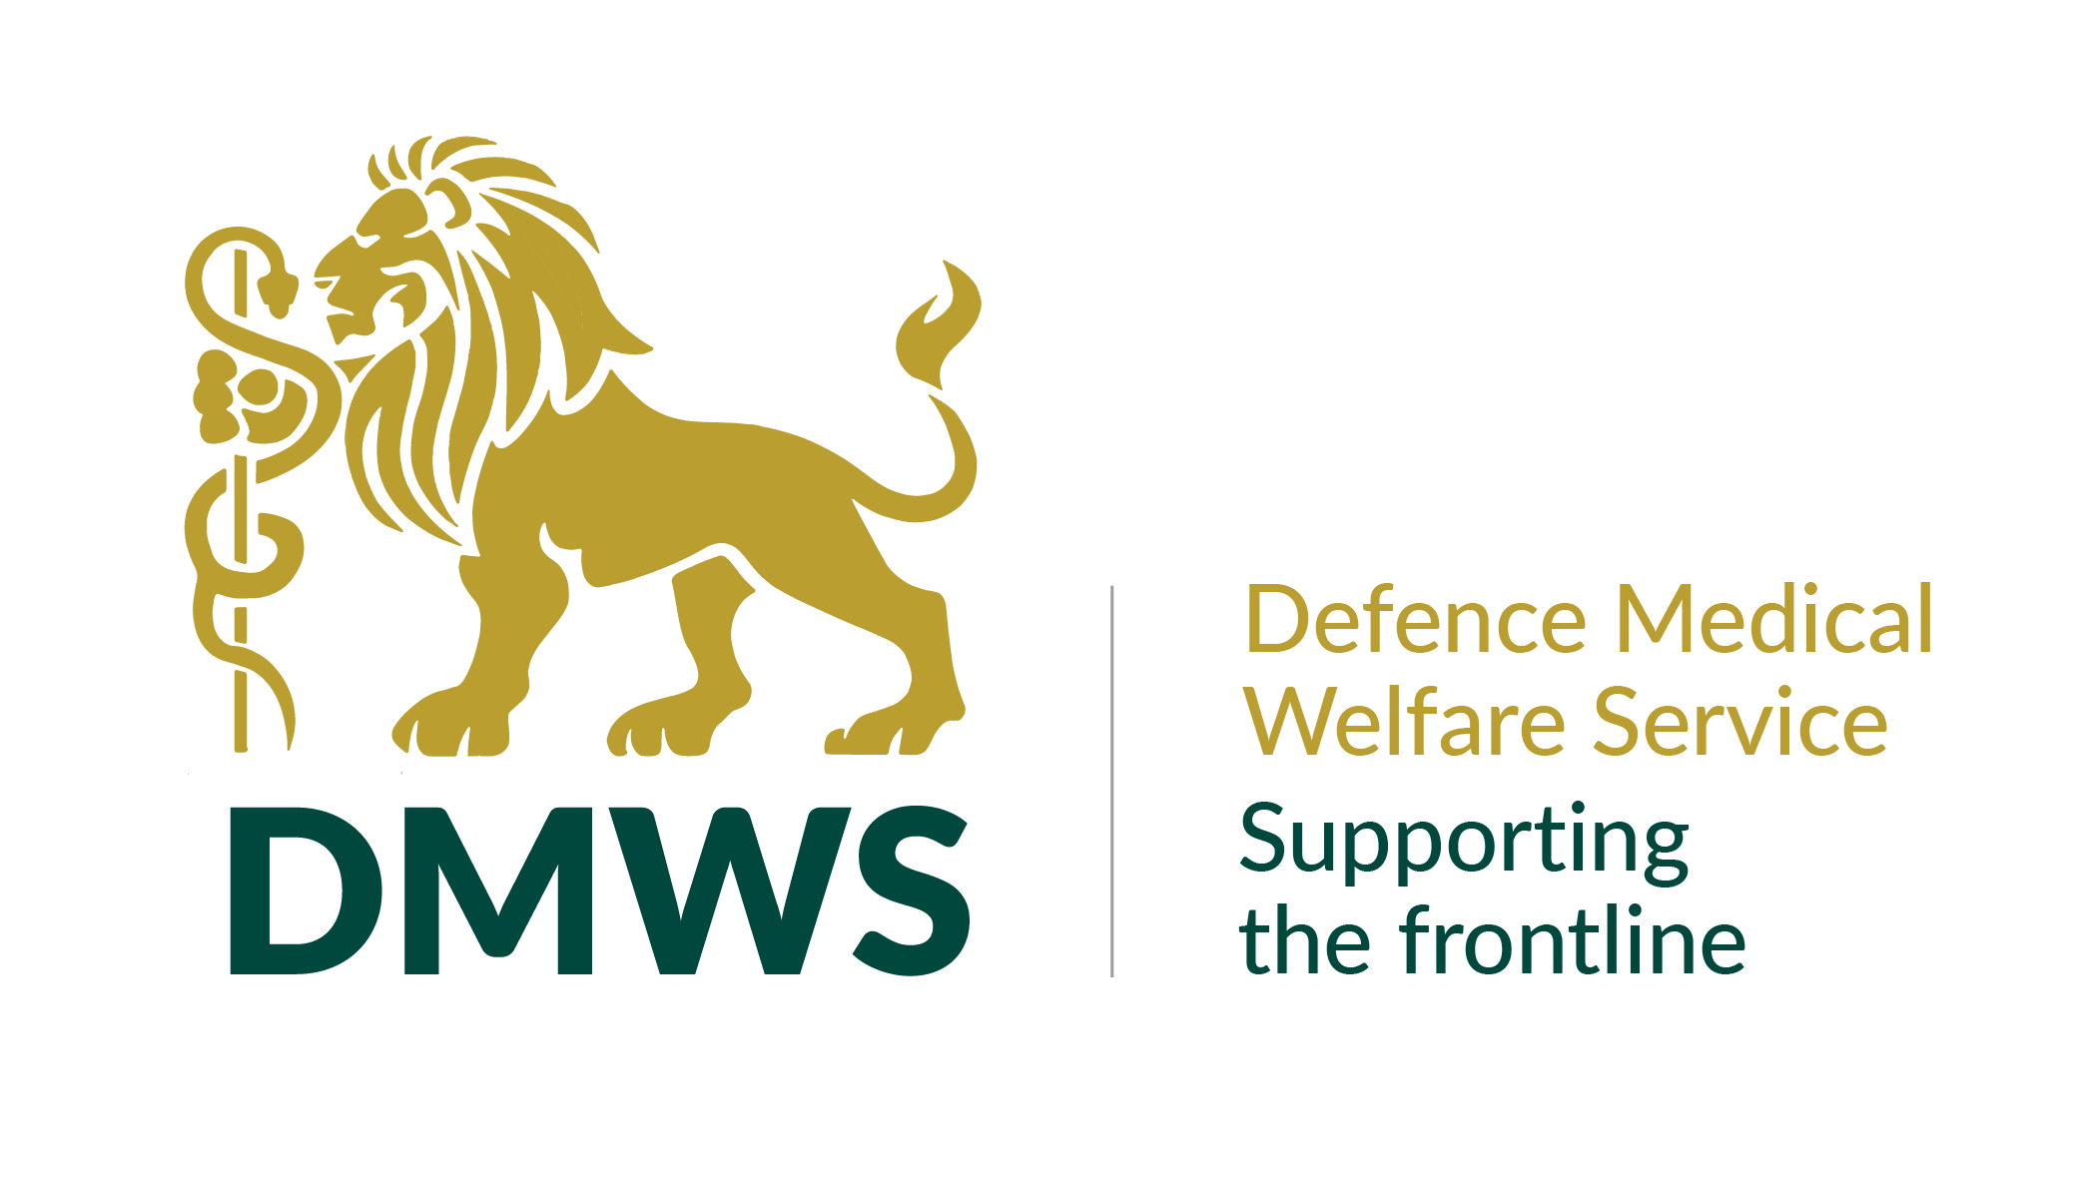

DEFENCE MEDICAL WELFARE SERVICE

FUNDRAISING OFFICER

JOB DESCRIPTION

**Primary Outputs**

To raise funds through high-quality bid and application processes which includes supporting the development of funding applications and evaluation reports based on good research and excellent communication. All the work must ensure that DMWS’ mission, values and aims are clearly articulated in a professional manner and that our vision for sustainability and growth to support our beneficiaries is successful.

**Key Responsibilities**

* Contribute to the writing of consistently high-quality funding applications and bid documents which are accurate, substantiated, and contain compelling content. Ensure these are submitted to deadline and in line with the funders criteria as well as DMWS aims.
* Write, edit and submit evaluation reports as required by the funder – working with operational colleagues for support.
* Develop, update, and maintain an electronic project bid library resource, including written templates and application responses.
* Maintain an up to date register of all grant and trust fund providers applied to for projects, submission deadlines, and other relevant information, including timeframes for re-applying.
* Research and assess potential opportunities to obtain funding from grant making trusts and foundations, organisations, in order to sustain and develop DMWS services against strategic aims.
* Contribute to sustainability plans for existing services and contracts to ensure they are extended, renewed, or expanded according to the strategic goals of DMWS and in line with existing funding or new sources of funding.
* Support the exploration and development of opportunities with Corporate Partners and Major Donors as funding streams.
* Identify and build strong internal and external relationships.

As and when required, attend at various meetings and events at headquarters or other locations.

Work with other head office and operational colleagues to share intelligence and contribute to the delivery of DMWS Strategy and organisational sustainability.

**General Support Tasks**

* Promote the vision, mission and values of DMWS
* Contribute creative thinking, ideas and support to colleagues to help facilitate the promotion of a positive organisational environment.
* Represent and promote DMWS and its services, working with and supporting other staff, maintaining a positive and professional approach with all contacts both internal and external.
* Engage in, and undertake with enthusiasm, all opportunities for training and professional development in order to achieve additional skills as the role and organisation develops.
* Adhere to the terms and conditions of employment working within the policies and procedures of DMWS.
* Be responsible for own safety and others affected by your activities and to ensure adherence to DMWS’ policies and procedures regarding Health & Safety, GDPR, Data Protection, and confidentiality.
* Develop and maintain effective communications within DMWS to optimise outcomes.
* To establish and maintain links to other organisations relevant to the post, and to ensure that those links are shared as appropriate.
* To be aware of, and work to, safeguarding principles, practice and procedures.

The list of duties in the job description should not be regarded as exclusive or exhaustive. There will be other duties and requirements associated with the role and, in addition, as a term of employment you may be required to undertake various other duties as may reasonably be required

**Person Specification**

* Experience.
* Excellent communicator.
* Demonstrable experience of securing or involvement in funding through bid writing and funding applications.
* Demonstrable ability to communicate compelling messages in written form.
* Experience of coordinating and updating a knowledgebase system.
* Experience in organising, prioritising, and managing your time effectively.
* Creative instinct and ability to think laterally about new business opportunities.
* Collaborative and adaptive working.
* Experience of raising funds within the third sector.
* Experience of research and data analysis.
* Experience of working within the health, social care, wellbeing, or military third sector is desirable but not essential.
* Experience of working within project delivery or project development is desirable but not essential.

**Skills**

* Strong interpersonal skills that enable you to communicate internally and externally, and the ability to engage clearly with people at all levels.
* Excellent written and verbal communication skills.
* Accuracy and management of deadlines.
* Team working skills and the ability to work independently with little direction to prioritise work areas.
* Excellent IT skills including use of Word, Excel and PowerPoint Packages.
* Confident, self- motivated, target driven, strong team player.
* Ability to work under pressure and to demanding deadlines, delivering objectives to agreed timescales.

**Personal Qualities**

* The ability to deal positively within deadlines and presenting information with accuracy
* A flexible approach to work.
* Willingness to travel to DMWS HQ and other locations as required, with some overnight stays, and occasional weekend work.
* Proactive, committed, and forward thinking.
* Engaging manner and personality with the ability to forge effective working relationships with a range of staff and other stakeholders.
* Personal sensitivity, empathy, and flexibility to operate within the distinctive ethos and structure of DMWS.
* Strong commitment to DMWS’ aims of providing medical welfare services to those in need.

**BENEFITS OF WORKING WITH DMWS**

We recognise that our staff are the most important asset that we have. We offer employees the following benefits in recognition of their work:-

**Annual Leave**

We give employees 30 days a year annual leave plus Public Holidays (pro-rata'd for part-time employees).

**Pension**

Auto enrolment onto DMWS workplace pension scheme – subject to eligibility. You will make a minimum contribution of 5% which DMWS will match. Contributions will be matched up to 6% by DMWS.

**Death in Service Scheme**

Three times your annual salary to nominated beneficiaries - subject to eligibility

**Flexible Working**

All flexible working requests are considered - many of our staff work flexible hours and work wholly, or partly from home.

**Smart Health**

Access to a 24/7 virtual GP service, with a counselling service and on-line help and support around health and well-being matters

**Work-based Parking/Mileage**

For those who pay to park at their work-base, fees are repaid through expenses.  Mileage claims are reimbursed in line with HMRC guidelines.

**Enhanced Sick Pay**

Enhanced sick pay scheme for all employees upon completion of their probationary period.

**Staff Recognition**

Staff are regularly recognised for their work by the leadership team and their peers, via internal events, social media, and industry awards.

**Personal Development Programme**

DMWS supports employee continuing professional development and training.